GroupUnion
- Display the name and the corresponding description based on the candidates salary (Use union and be cautious of the types) Order by name
< 50000 Honest
>50000 and < 100000 Not so honest
>100000 80000
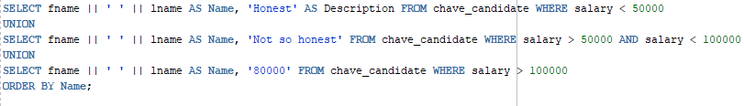

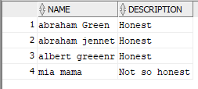
- Display the name and the corresponding description based on the candidates salary (Use a plain case statement in chapter 5)
< 50000 Honest
>50000 and < 100000 Not so honest
>100000 80000
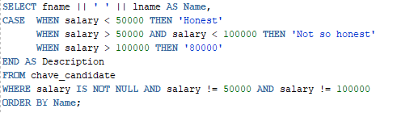

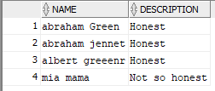

3) Display the name of all the people who are not associated with a party (use not in). This is a bit tricky because people who don’t have a party_id will have a null and you cannot compare a null using not in because it doesn’t know how to deal with non-data. You can put the party_id in an NVL function in the where clause to resolve this issue
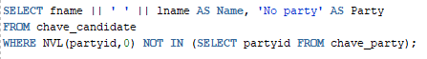

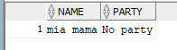
4) Repeat question 3 using (not exists)
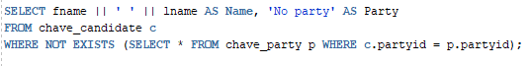

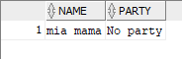
5) Repeat question 3 using (minus)

